Shabbos Stories for
Parshas tetzaveh 5781
Volume 12, Issue 27 15 Adar/February 27, 2021
Printed L’illuy nishmas Nechama bas R’ Noach, a”hs

For a free subscription, please forward your request to keren18@juno.com
Past stories can be found on the website ShabbosStories.com

The Runaway Convert
By Elchonon Isaacs

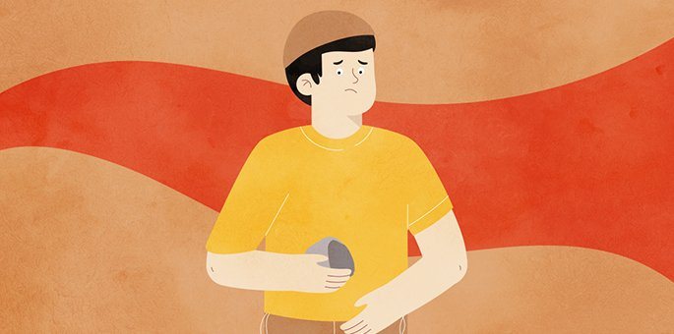
Illustration by Rivka Korf Studio

Wine flowed and words of Torah were shared as the Jewish community of Ratzfert (Újfehértó), Hungary, gathered to welcome their new leader, Rabbi Naftali Hertz Halevi.
The atmosphere was jubilant, and the choicest fish, meat, and wines were served.
Suddenly a cry erupted at one of the tables. “Yayin nesech! Non-Jewish wine!” someone shouted. The lone voice soon became a din. As the bottle in question was passed around, it became apparent that there was a cross illustrated on the label, indicating that the wine had been manufactured at a non-Jewish winery, rendering it unfit to be used.
The bottle made its way up to Rav Yechezkel Shraga of Shineve (Szeniawa), oldest son of the saintly Rav Chaim Halberstam of Tzanz (Now Sącz), and a dear friend of the new rabbi.
As he inspected it, a faint smile crossed his lips. This surprising reaction calmed the commotion. All waited for the visiting sage to explain.

The Roof Fell Silent
As the room fell silent, the rabbi began to tell a story:
Years ago, in one of Warsaw’s upscale neighborhoods, lived a rich widow named Paula Zimorsky. Among the many assets her late husband left her was a large winery.
When a Jewish merchant arrived at her estate one day, a rock was thrown at his head. He looked around and noticed a young boy with a cruel grin peeking out from behind the bushes. It was the widow’s son.
As the injured Jew met with her, he bemoaned the “warm welcome” he had received from her son. Shocked, she didn’t hesitate to apologize. “Maybe my preoccupation with my business affairs did not leave me enough time to invest in raising my child,” she sighed.
After the Jewish businessman left, the mother called her son and reprimanded him. The child looked at his mother in surprise. His eyes conveyed his thoughts: Mom, what’s the big deal? After all, he is just a Jew.
Noticing the unspoken sentiment, she said, “Know, my son, that the Jews you despise are G-d's chosen people. I believe that their religion is right and just. You should know, my dear that Christianity and Islam feed off ideas borrowed from Judaism.”

The Boy Stared at His Mother
Never expecting to hear such words, the boy stared at his mother and asked, “Why did you never act on your convictions and become a Jewess?” The mother thought for a moment and chose her words carefully. “After all is said and done, I think that a person ought to follow in the path of their parents and to continue the traditions and beliefs that they were brought up with.”
It did not take long before people began to notice the improved behavior of the rich, spoiled orphan boy, but nobody knew what had caused the change. In truth, since that heart-to-heart conversation with his mother, he was besieged by troubled thoughts that gave him no rest.
Years passed, and one day the boy (now a teen) left home without a trace. He wandered until he chanced upon the house of a melamed (Torah teacher) in a village outside of Lublin. The teacher agreed to help this young Christian lad who demonstrated a genuine yearning to learn.

Chose the Name Dovid
A short time passed and the young man went through a full conversion and chose the name Dovid. He began to advance in his learning and soon became a noted Torah scholar with a large and devoted following. People did not know his background, but his brilliance and eloquence were unparalleled.
One day two police officers stormed the study hall and arrested Dovid. In the church’s dark cellar, Dovid was charged with contempt for the Christian religion and was subsequently burned at the stake.
Some time passed and two priests disappeared from a church in Warsaw. After a few months, a letter arrived from the Holy Land. In the letter, they recounted the long conversations they had had with Dovid, and admitted that they had converted to Judaism as a result.
The second episode was even more embarrassing to the church than the first. The church leaders met and decided that the cause of all this trouble was the poor education the widow Zimorsky gave her child. In light of this, they determined that her wines could no longer bear the symbol of Christianity on their labels.

Shocked When He Saw the Bottle Labels
Years passed, concluded Reb Yechezkel Shraga, and the winery was bought by a G-d-fearing Jew, a member of my congregation. At first, he was also shocked when he saw the bottle labels and wanted to alter them. But when he heard this story, he chose to keep the labels to immortalize the sanctification of G-d’s name by Dovid, the son of the widowed Zimorsky.
Look again closely at the label and you will see that it is not a proper cross, it is only similar, as the church forbade the woman to use the symbol of their religion.

Reprinted from the Parshat Beshalach 5781 email of Chabad.Org Magazine. Translated and adapted from a story found in Sichat Hashavua #501.

How Much Do You Trust?
By Rabbi Dovid Goldwasser

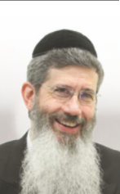

“I shall rain down for you food from heaven; let the people go out and pick each day’s portion on its day…” (Shemos 16:4).
The Talmud (Yoma 76a) relates that the students of R’ Shimon bar Yochai asked: Why didn’t the mahn just fall once a year? R’ Shimon bar Yochai answered with a parable: A king with an only son would give him an allowance for which the son would visit his father once a year. The king decided, though, that he wanted to see his son more often, so he only granted him enough provisions for one day; that way, his son had to visit him every day.

By daily receiving enough mahn for only one day, the Jewish nation had to constantly direct their hearts to Hashem for His sustenance in the midst of the desolate desert.
It is told that a rich man came one Motzei Shabbos to R’ Yaakov Chizkiyah Greenwald, the Puppa Rebbe, and gave him a large sum of money. The next Motzei Shabbos he came again and again gave the Rebbe a large sum of money. When the wealthy man returned the third Motzei Shabbos with a monetary gift, the Admur refused it, saying, “You have already given me enough.”
The wealthy man said, “I have a lot of money and my gifts to you have brought me much beracha. Why can’t I give you more money?”
“If I know I can get money at any time,” responded the tzaddik, “it will wear away my bitachon, my trust and faith in Hashem.”
It’s interesting to note that when Lavan told Yaakov (Bereishis 30:28), “Specify your wage to me and I will give it,” Yaakov responded, “Don’t give me anything.” The Radak comments that Yaakov wanted his sustenance to come from the goodness of Hashem, as we say in Birchas HaMazon, “Make us not needful of the gifts of human hands…but only of Your Hand that is full, open, holy and generous….”
R’ Avraham Yehoshua Heschel of Apt, the Ohel Yisroel, would often tell of an innkeeper who became a miracle worker. It was said that whatever beracha the innkeeper gave would eventually be realized. His fame spread far and wide and reached the ears of the Ohev Yisroel.

The Tzadik was Troubled
The Ohev Yisroel was troubled, fearing that the man was perhaps resorting to black magic or secrets of Kabbalah to perform miracles and decided to travel to the city where the innkeeper lived to observe him. He stayed there for a while to monitor the innkeeper’s ways and was happy to note that nothing seemed amiss. The innkeeper seemed to be a typical Torah-observant individual.
Finally, the Apter approached him and revealed who he was. He then explained that he wanted to learn the innkeeper’s secret to having his berachos fulfilled.
The innkeeper replied humbly, “I’ll be honest with you. I have placed all my faith in Hashem. There was a time when my business failed, and we were destitute. There was no money at all, and the family was going hungry. My wife was distraught and advised me to travel to a different city and find a partner who would invest in my business. I was reluctant to do that, but my wife insisted.

Made a Partnership Deal with Hashem
“As I was walking through the forest on the outskirts of the city, I had a thought. I called out to Hashem: Master of the world, in the Grace After Meals we ask, ‘Make us not needful of the gifts of human hands nor of their loans.’ I do not want to be partners with a human being. I want You, Hashem, as a partner, and I promise that we will be equal partners. Everything will be divided 50-50.’
“I then returned home and intensified my faith and trust in Hashem. Every dollar of profit was divided, with half going to the poor people who desperately needed tzedakah. Ever since that day,” concluded the innkeeper, “my business has flourished. I cannot adequately thank my ‘partner’ for all the blessing I have in life.”
Upon hearing these words, the Ohev Yisroel blessed the innkeeper, “May there be many like you in the nation of Israel.”

Reprinted from the January 28, 2021 website of The Jewish Press.
A Cup of Tea for
Rav Leib Chasman

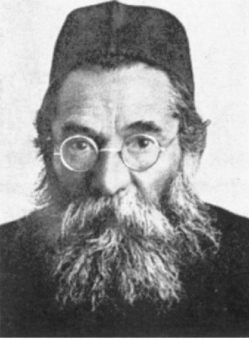

R’ Leib Chasman, famed mussar giant of the Chevron Yeshiva in Jerusalem in the early twentieth century, was speaking to a boy who had come to him asking how to improve his service of Hashem. After some discussion, R’ Leib asked the bochur to go to the Rebbetzin in the kitchen and ask her for a cup of tea for him. The boy jumped up to do as he was asked. As he did, R’ Leib grabbed his arm. “Wait! Why did you jump up so quickly?”
The boy hesitated, thought a moment, and then replied, “I guess I ran because I have the opportunity to serve a Talmid Chacham!”
“Oy,” sighed R’ Leib. “It is exactly as I thought. A young man is presented with the chance to improve his Avodas Hashem by doing a true kindness for another and bringing a feeble old man a cup of tea. However, instead of focusing on doing kindness for its own sake, he chooses to focus on other considerations like serving Torah scholars, which in my case is even questionable.”

Reprinted from the Parshas Yisro 5781 email of Migdal Ohr.

What Does the Jewish Last Name Rapoport Mean?
By Menachem Posner

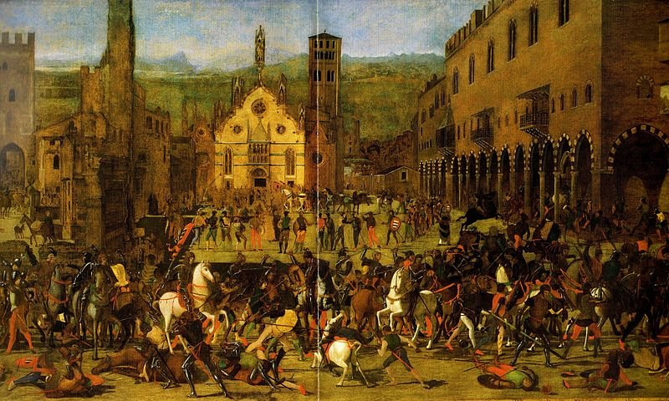
Old drawing of a battle in Mantua - the province seat of the town of Porto (Porto Mantovano).

Today, Rappaport, Rappoport, Rapoport and Rapaport are all common Jewish family names, found both among Ashkenazi and Sephardi Jews. The name was borne with pride by successive generations of rabbinic leaders and their families since the 15th century. Although shrouded in mystery, there are certain facts we know for sure about this name:
This name was historically associated with members of the priestly clan (kohanim). However, in part because people at times inherited prestigious last names through the female line and priesthood is passed from father to son, there exist many Rappaports today who are not kohanim.
The second half of the name is linked to the Italian city of Porto in the province of Mantua, Lombardy, Italy.
We are still, however, left scratching our heads regarding the provenance of the Rap or Rappa half of the name (which also appears to be an independent name).
Online research reveals that some have linked it to the word “rabbi,” implying that contemporary Rappaports are descendants of the rabbi of Porto. However, it is more likely that it is an unrelated term, possibly the German word for “raven,” which is supported by the fact that certain prestigious members of this family had a raven included on their coat of arms.
Some famous Rappaports include:
● Rabbi Yitzchak Rappaport (1685–1755), who was born to Polish parents and grew up to become the chief (Sephardic) rabbi of the Holy Land
● Rabbi Chaim Rappaport (?–1771), rabbi of Lvov (Lemberg), a close disciple and colleague of the Baal Shem Tov

Reprinted from the Parshat Yitro 5781 email of the Chabad.Org Magazine.

‘Protection from Above’ – 'עליונה שמירה'

This happened when I was beginning to get close to Yiddishkeit. The journey was long and arduous, but I strengthened myself day to day in avodas Hashem, and continuously accepted on myself another mitzvah to keep. The journey was filled with ups and downs, and I always had to renew strength in every holy thing, the same held true for putting on Tefillin, difficult encouragement and difficult battles with the yetzer.
We were on maneuvers and we were travelling every day, so I did not have time to put on Tefillin. I felt bad about it but I had no choice until just about sunset when we stopped to rest a little from the long trip. Immediately when we stopped, I told the driver to come with me to put on Tefillin.

He tried to refuse because he was exhausted and he wanted to rest a little, but he could not refuse my insistence knowing that I would not let him be until he put on Tefillin. Since I left him no choice, he accompanied me to the back of the military vehicle and I took out my Tefillin bag and we put on Tefillin, me first and then him.
I helped him put on the Tefillin and when he said the first posuk of “Shema Yisrael” a missile exploded destroying the front half of the carrier, exactly where the driver was going to rest and gather strength to continue. We all got out without a scratch, except a ringing in the ears.

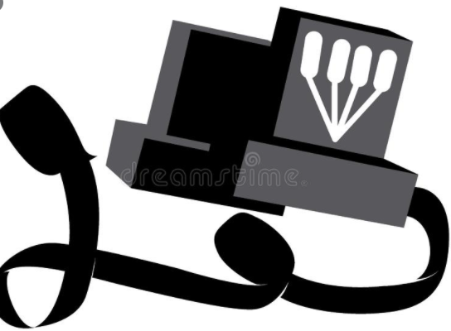

It was clear to us that the merit of the Tefillin saved our lives. From that day on, he stood by me in line every day, close friends putting on Tefillin, and it was a great encouragement to all, how the mitzvos protect us. It is important for me to point out that I do not usually push myself on others. Whoever does not want to do something loses out, but here, it was from Heaven that I was a nudnik and I urged him to put on Tefillin, something against my nature. (By A.B.D.)

Reprinted from the Parshas Yisro 5781 email of Tiv Hakehila.

Sages Under the Stars

Rabbi Moshe Karelman, a brilliant Talmudist and his star pupil Yeshaya are traveling to Vilna when they have to stop for the night, and pitch their tent in an empty field. After the evening prayers Rabbi Karelman and Yeshaya retire for the evening.
Some hours later, Rabbi Karelman wakes up and nudges his student. “Yeshaya, look up at the sky and tell me what you see.”
“I see millions and millions of stars, Rabbi Karelman.” “And from this, what do you deduce?” Yeshaya ponders for a minute. “Well, astronomically, this view conveys the vastness of the heavens. Chronometrically, I deduce that the time is approximately a quarter past three. Meteorologically, I suspect that we will have a beautiful day tomorrow. Theologically, I can see that G-d is all powerful, and that we are a small and insignificant part of His universe. What does it tell you, Rabbi Karelman?”
“Yeshaya, someone has stolen our tent.”

Reprinted from the Parshat Mishpatim 5781 email of Lekavod Shabbos Magazine.
Story #1210

Saved by Covid-19!
From the desk of Yerachmiel Tilles
editor@ascentofsafed.com

In the Israeli town of Rechasim, near Haifa, a young orphan recently [January 2021] celebrated his Bar Mitzvah. His mother is a poor widow and they really have no money. The boy gets great pleasure from spiritual music, soulful Chassidic nigunim-- wordless melodies -- and appreciates hearing talented singers.
The mother contacted Mr. C, a kind businessman who helps her financially. “Please do my son a great favor. He has no father. Bring an excellent singer to his Bar Mitzvah. It will bring him such happiness.”
So, this Mr. C contacted a particular local professional singer who he knew would fit the bill. He explained to him upfront that there was no money to pay for his services.
The singer shrugged and responded, “This is my living. I can’t perform for free.”
Mr. C refused to take “no” for an answer. “The boy has no father. Along with the current lockdown restrictions it will be a sad occasion. You can make it into a time of joy. Remember: the Rambam teaches that there is no greater pleasure for G-d than when we gladden the hearts of widows and orphans.”
The orphan boy’s situation touched the singer’s heart and he agreed to perform at no cost. At the celebration, he sat near the Bar Mitzvah lad, and each time he got up to sing, everyone felt uplifted. Thanks to him, it became an exciting and lively event, and was a huge success. For that night, the young boy forgot all his worries.
Two days later, the singer receives a surprise phone call. “The Bar Mitzvah boy has Corona. You have to quarantine for two weeks.”
The singer was so upset. “I give up one night of work to sing for free and now I can’t earn any money at all for two whole weeks!”
After another few days and the singer arranges to be tested. He is devastated to find out that he has Corona himself! “This is my reward for the mitzvah of bringing joy to an orphan?” he thinks. “Another two weeks without work! Why is this happening to me?”
Finally he recovers from his illness, and starts to seek new bookings locally. But then he is contacted by an organization in New York that arranges Bar Mitzvah celebrations for orphans. They are arranging a lavish event for boys who have become Bar Mitzvah in the past few months. There were to be a number of top-class entertainers there, and they wanted him to be one of them. They offered to fly him in for a very generous payment, more than he would earn from many nights of work, more even than he would have made during his entire period of isolation. Not only that, this could be a special opportunity for him, a breakthrough to the world-stage.
“How did you hear about me?” he asked wonderingly. They answered that someone from the organization had attended the Bar Mitzvah of the orphan and was very impressed with the way he had transformed the event to be so lively. So they decided that it was highly desirable that he too should perform at this event.
“However”, said the organizer, “we cannot take the risk that you might possibly infect others, especially since you would be coming from Israel. So, there is one condition; otherwise, we can’t hire you:
“You must already have been ill with Corona and have fully recovered!

~~~~~~~~~~~~~~~~~~~
Source: Adapted by Yerachmiel Tilles from the video recording of Rabbi Elimelech Biderman telling this story [in Yiddish with English subtitles.
Postscript to this story by Rabbi Biderman:
We never lose from doing a Mitzvah!
Connection : The weekly reading of Terumah opens with a list of a large variety of monetary and non-monetary donations. Time is also a donation!
Two more postscripts, from the editor:
Refrain from making snap judgments about the Al-mighty’s decisions. It may take a while, maybe even a long while, but everything that descends from Heaven is [ultimately] for good -- YT
“I, G-D, am your healer” can sometimes mean that HE assigns us an illness for a specific good purpose (not just that suffering purifies the soul). -- YT

Reprinted from the Parshas Terumah 5781 email of KabbalaOnline.org, a project of Ascent of Safed.
“Amar Rebe Binyamin” Israeli Journalist Astounded: “I Davened & Found My Wallet!”

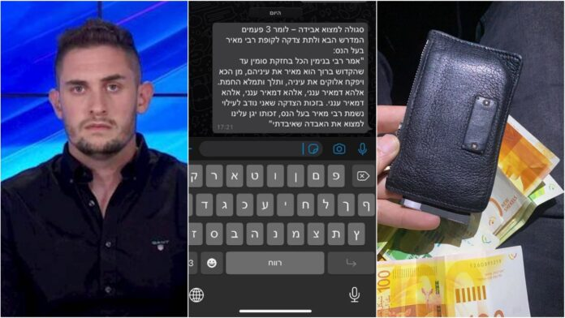

A well-known secular journalist in Israel, Yediot Achronot journalist Liran Tamari, posted on social media about an astounding incident he experienced on Monday.
“I must share this crazy story,” he wrote. “This morning, in central Jerusalem, I lost my wallet with credit cards, NIS 1,000 cash and my teudat zehut (identity card) in it.”
“I searched the streets for hours unsuccessfully. Then a friend sent me a tefillah for finding lost objects called ‘Amar Rebbe Binyamin.’ [I said the tefillah] and shortly later, I received messages on Facebook from people who found my wallet on the street with the money inside. Astounding!”
Tamari revealed further details about the incident to B’Chadrei Chareidim. “They found my wallet in parts on Rechov Betzalel. I had already lost hope in finding it and then a friend sent me the tefillah and I said it three times.”
“A couple of hours later, I began getting messages. One person said that he found my credit card. A few minutes later, another person messaged me that he found my wallet. I asked him if the NIS 1,000 was in it and he said yes. A few hours later, another man messaged me that he found another credit card.”
“I’m a maa’min, I try to put on tefillin” Tamari added. “I was depressed all day about the wallet. Then my friend reminds me of this tefillah and then suddenly I receive a flood of messages that my wallet was found in parts. Unbelievable.”
(YWN Israel Desk – Jerusalem)

Reprinted from the February 18, 2021 website of Yeshiva World.

What is Better: A Chassidic Rebbe or Friends?

One evening, a group of Chasidim were sitting in the Bais Medrash of the Rebbe of Rozhin. Suddenly, the Rebbe came over to them and approached one of the surprised Chasidim, and asked him, “Please tell me, what is better, a Rebbe or friends?”
Upon hearing the question, the Chasid panicked, but then he lowered his eyes, and without hesitation, he replied, “Friends are better.”
The Rebbe smiled when he heard the answer, and he went back to his room. The other Chasidim who witnessed the exchange were quite surprised by their friend’s response, and immediately rebuked him and said, “How can you be so brazen and Chutzpadik to talk like that to the Rebbe?!”
The Chasid responded, “You should know that all the words of the Rebbe are said with Ruach Ha’kodesh! Please listen, and I will tell you a story. On my way over here, I stayed overnight at an inn, and in the middle of the night, I was confronted with a very difficult challenge in Kedushah. The Yetzer Hara burned in me like a fire, urging me to commit a terrible Aveirah, but suddenly, I remembered that when I will come to the Rebbe, he would immediately be able to see what I did, just by looking at my forehead.
“In that instant, fear and shame fell on me, but then, the Yetzer Hara tried to convince me that it was possible to go to another Rebbe who would not be able to read my forehead, and I almost fell into his trap. But then I thought to myself, aside from the Rebbe, my good friends are there [in the court of the Rebbe] as well, and true, perhaps I can easily find another Rebbe, but it is not so easy to find good friends in another place. This is how I restrained myself from committing that terrible Aveirah. And now you understand why I told the Rebbe that friends are more important!”

Reprinted from the Parshas Toldos 5781 email of Torah U’Tefilah as compiled by Rabbi Yehuda Winzelberg.

In Search of a Sandek

It was a time of war. Troops of soldiers went between the cities and took advantage of the climate of battle to steal property and instill fear in the locals. Roads were treacherous to travel on, and thieves robbed travelers, and there was no one to stop them. Mainly, those living in villages and small cities lived in fear because they had no protection.
In a small village near Zelichow, Poland, a Jewish boy was born. His father had run off some time earlier to hide, out of fear that he would be drafted into the Polish army, and the young mother was left alone. She decided that she would do whatever she could to get her child to have a Bris on time, and bring him into the covenant of Avraham Avinu on the eighth day after his birth.
She happened to find a passerby on his way to Zelichow, and she pleaded with him to go to the Mohel, Rav Gedaliah, and ask him, in any possible way, that he come to circumcise her son. Rav Gedaliah, who was a student of the Maggid of Mezritch, accepted the request, and it touched his heart.
His Family Begged Him Not to Go
His family begged him not to go out on the road since it was so dangerous, but he told them that messengers on the way to do a Mitzvah are not harmed. Rav Gedaliah took his bag with his Bris Milah implements, and he left to go to the village. The trip was not easy, and occasionally, he would jump from the noise around him. Every loud sound shook him to his core, but in the end, he reached the house of the mother who had given birth, in peace.
He examined the baby and found that he was indeed fit for the Bris. Now, he turned to the woman and asked her where her husband was or where he could find another man to be the Sandek and hold the baby during the Bris Milah. The woman told him that her husband and every other man in the village fled and hid to avoid the army, and she had no idea where they were.
Rav Gedaliah assessed the situation. He had never arranged a Bris without a Sandek, but if he did not do the Bris now, the Milah would be pushed off indefinitely. He checked to see if he could hold the baby and do the Milah by himself, but he realized that it was just not possible. He needed someone to help him, but he had no idea where he could find a man to help him.
Waited a Long Time Looking for Another Jewish Man
Rav Gedaliah went out to the crossroads. He waited a long time looking for someone, hoping that perhaps someone would pass by who could help with the Mitzvah. Suddenly, in the distance, he saw a Jewish man approaching. With much excitement, Rav Gedaliah ran to him and happily called out, “Reb Yid! You came just in time. Can you please help me? I need you to serve as a Sandek for the Bris of Avraham Avinu, and I will circumcise the boy! Please come with me.”
Happily, Rav Gedaliah turned back to head to the new mother’s house. He had no doubt that the man would hurry after him and gladly fulfill the great Mitzvah, but when he looked behind him, the man did not follow him, he just continued on his way. Rav Gedaliah did not give up. Since HaKadosh Baruch Hu sent him a man, how could he give up?! He chased after the man and used all his powers of persuasion to get the man to come along with him, and finally, the man agreed.
On the way, he tried to engage the man in conversation, but the man practically said nothing. Rav Gedaliah saw the man carrying a stool on his back, and Rav Gedaliah understood that he was a shoemaker. When they arrived at the new mother’s house, the shoemaker took the stool, placed it on the ground, and sat on it. Rav Gedaliah saw that the man was not helping at all, and he was also not answering any questions, and he decided that the man was not comfortable with this.
Grateful to be Able to Do the Bris
He thanked Hashem for giving him the opportunity to perform the Bris. He quickly took the baby in his expert hands and placed him on the knees of the shoemaker. The shoemaker looked on with a blank expression, but he held the baby properly, and Rav Gedaliah began the Milah. Rav Gedaliah began to recite the Brachos in a loud, emotional voice, “Baruch Atah Hashem… Al HaMilah,” and then, “…L’Hachniso Bi’briso Shel Avraham Avinu.”
The mother, who was standing on the side, was crying tears of joy, in that she merited to arrange a Bris Milah for her son on time. In just a few moments, the Mohel had finished, and placed the baby back in his cradle. Just then, the strange shoemaker took out a bottle of wine from his sack and gave it to Rav Gedaliah. Surprised, Rav Gedaliah was filled with happiness, since there was no wine in the house, and he thought that he would just recite the Brachos without a cup of wine. Rav Gedaliah quickly filled a cup to the brim, and with a pleasant voice he began to recite, “Asher Kidash Yedid Mi’beten’, ‘Who sanctified the beloved one from the womb’.
When he recited the Brachos, his eyes were closed with concentration and D’veikus, attachment to Hashem, and when he opened his eyes at the end of the Brachos, to his astonishment, the shoemaker had disappeared! He could not explain how in a moment the shoemaker disappeared with his sack and the stool that he sat on.
Was That Eliyahu HaNavi?
Rav Gedaliah thought to himself, “Perhaps this was Eliyahu HaNavi who came at just the right time to help with the Bris!” With much excitement, he left the new mother and returned to Zelichow. His heart was very uplifted in the Zechus of the Mitzvah, and with the thought that perhaps he merited to be helped by Eliyahu HaNavi! He traveled without incident, and when he arrived home, his family rejoiced with him, and they thanked Hashem for his safe return.
Several months later, the war was over, and the land settled down. Rav Gedaliah went to Mezritch, to see his Rav, the Maggid, to receive Brachah and Chizuk, strength and encouragement. He waited at the side of his Rebbe’s room, and when his turn came, Rav Gedaliah opened the door with trembling.
He had only taken one step inside the room, and the Maggid called to him affectionately, “Rav Gedaliah! You were happy when you thought that the shoemaker who held the baby on his knees was Eliyahu HaNavi, but your joy should increase many times over to know that it was not Eliyahu HaNavi that you merited to see, but rather it was the actual Baal HaBris himself! You were Zocheh to have Avraham Avinu be the Sandek at that Bris!”
Reprinted from the Parshas Toldos 5781 email of Torah U’Tefilah as compiled by Rabbi Yehuda Winzelberg.

The Segulah of
The Number 138

Rebbe Moshe Mordechai of Lelov, zt”l, the Lelover Rebbe, was once approached by a Bachur who asked for a Brachah, because he was about to be drafted into the army.
The Rebbe said to him, “When people come to me with their problems, I recommend that they donate the value of 138 rubles to Tzedakah, because the word Hatzlachah, which means success, has the same Gematria, numerical value, of 138. But you are a Bachur and you don’t have so much money. So instead, I request that you learn 138 pages of Gemara.”
The Bachur listened to the advice of the Rebbe, and on the day this boy finished the 138th page, the army notified him that he was exempt from service!
Reprinted from the Parshas Toldos 5781 email of Torah U’Tefilah as compiled by Rabbi Yehuda Winzelberg.

